Total Mark: 50 | % | Weight  20%

BAHASA INDONESIA
Year 8 Viewing, Reading & Responding Term 2 Semester 1
My estimated score out of 50: ____________
Respond to each of the questions and complete the tasks set in
the space provided throughout this paper.
SECTION A: View the following images and respond to each task accordingly.
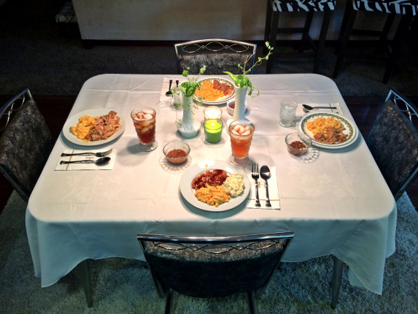
(Image 1)
- List the Indonesian words for at least six items you can identify in Image 1?

________________________________
________________________________
________________________________
________________________________
________________________________
________________________________
(6 marks)

- Label the following food and drink items for each image below. (4 marks)
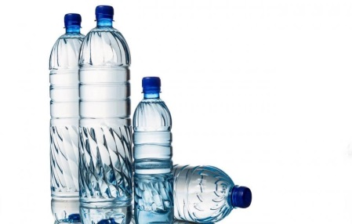
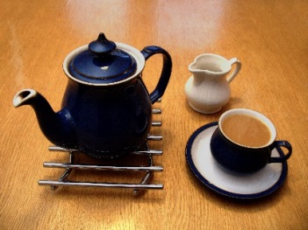

__________________ __________________
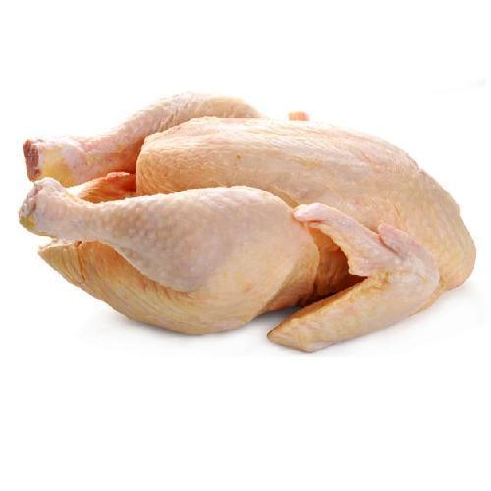
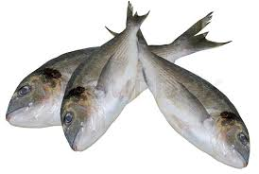

__________________ __________________

SECTION B
Translate the following texts into English. You will need to translate each sentence, word by word to get the main meaning. A sophisticated response would convert the word order so that is makes more sense in the English language

- Josh makan makan pagi. Dia suka roti dan mentega. (8 marks)
____________________________________________________________________________________________
____________________________________________________________________________________________

- Kami minum jus jeruk. Kamu pesan kopi. (6 marks)
____________________________________________________________________________________________
____________________________________________________________________________________________

- Teman-teman saya makan makanan di rumah makan. (6 marks)
____________________________________________________________________________________________
____________________________________________________________________________________________

- Anda minta daftar makanan. (3 marks)
____________________________________________________________________________________________
____________________________________________________________________________________________

- Boleh saya duduk di kursi dan meja? (7 marks)
____________________________________________________________________________________________
____________________________________________________________________________________________

- Mereka pesan kentang goreng dengan sambal. (6 marks)
____________________________________________________________________________________________
____________________________________________________________________________________________

SECTION C
View the images below and select the most appropriate word from the following list that best describes the rice stage or rice field in the image: (Padi; Sawah; Nasi; Beras) (4 marks)
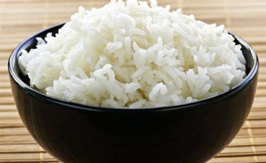

______________________ (cooked rice)

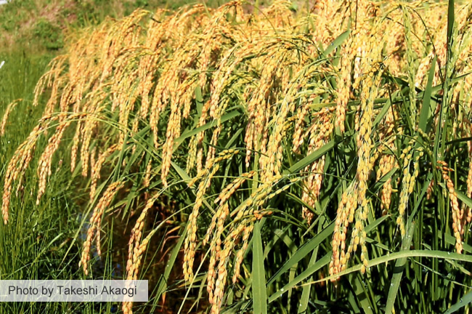

______________________ (growing rice)

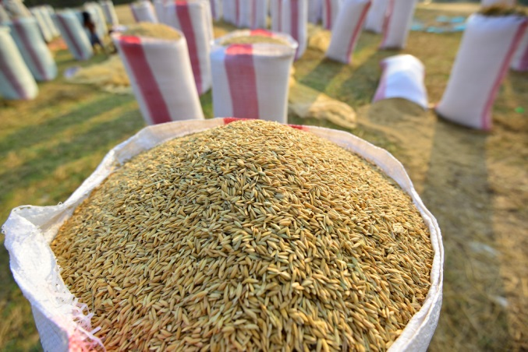

______________________ (harvested rice)

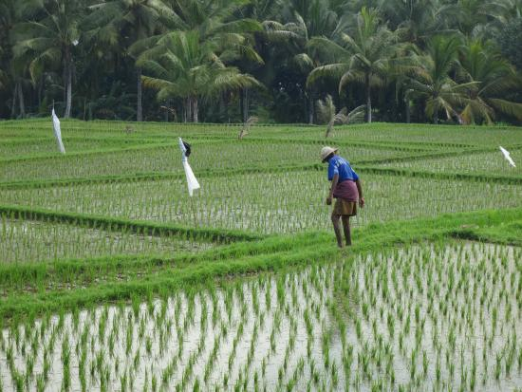

______________________ (a rice field)

